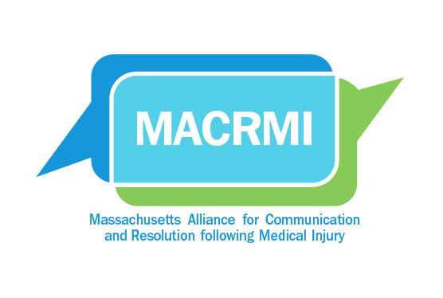
The Massachusetts Alliance for Communication
and Resolution following Medical Injury (MACRMI)

6th Annual CARe Forum
Agenda
Tuesday, May 15, 2018

Time | Topic | Presenter
10:00 | Welcome | MMS President
10:05 | Introduction of CARe and Simulation | Melinda Van Niel, MBA
10:15 | CARe: Behind the Scenes  Simulation, Part I
10:45 | Q&A with Panel Discussion on Part I | Moderator: Richard Boothman, JD
11:15 | Break
11:30 | CARe: The Work of Resolution  Simulation, Part II
12:15 | Q&A with Panel Discussion on Part II | Moderator: Richard Boothman, JD
12:45 | Break – Pick up Lunches
1:00 | Pilot Study Data Update | Michelle Mello, JD, PhD  Allen Kachalia, MD, JD
1:30 | CRPs: Where do we go from here? | Richard Boothman, JD
2:00 | Concluding Remarks | Alan Woodward, MD
2:15 | Forum End  MACRMI members remain available for discussion until 2:30

